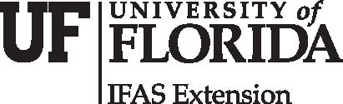
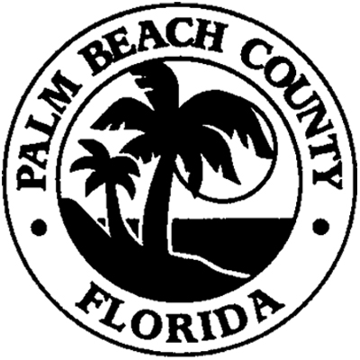

Palm Beach County

Palm Beach County Extension
University of Florida/IFAS
559 North Military Trail
West Palm Beach, FL 33415
561-233-1731
Fax: 561-233-1761
pbcgov.com/coextension/4h
fourh@pbcgov.org

DATE:

School you will be attending

RE: Donor Scholarship Recipient
Your Name:
Social Security Number: (LEAVE Blank; DO NOT EMAIL with your social!)

____________________________________________________________________________________

Award Funded LEAVE BLANK

Recipient
Name:
Address:
Phone #:
Email Address:

Institution Info
Check Payable to: Where and to whom check will be sent

Special Instructions
- Full-Time Student
- Disbursement
  - Fall 2022, Winter, 2022, Spring 2023, Summer 2023
- If for any reason student withdraws before receiving funds, please return monies to the above 4-H address

